Software Project Management Plan

Project: The Pearce Group Home Inspections Website Enhancement

March 10, 2021

Version 1.0

Sydney Pearce

Revision History

**Document History**

**Version Date Reason for Change**

0-0-1 03-10-21 Creating first version of SPMP

Preface

The following Software Project Management Plan (SPMP) describes the proposed plan to be taken to enhance the existing Pearce Group Home Inspection website. This SPMP includes the additional functionality that will be implemented to achieve the goal of this project: making company operations run smoother and take stress off of the secretary through added website features.

The scope of this project includes all design and implementation by developer Sydney Pearce, in order to get a functioning demo running by mid-April 2021.

The SPMP is intended to be used by Jeff Pearce, owner of Pearce Group Home Inspections, for the purpose of evaluating Ms. Pearce’s response and ideas to the proposed project requirements and set goal. Should Ms. Pearce’s response be accepted and chosen by the owner of TPG inspections to deliver the product, the SPMP shall also be used by Ms. Pearce as a plan and guide for conducting the product, as well as a reference to project plans and processes.

Table of Contents

Title Page………………………………………………………………………………………….1

Revision History…………………………………………………………………………………..2

Preface……………………………………………………………………………………………..3

Table of Contents..………………………………………………………………………………...4

Figures………………………………………………………………………………………......5-6

1. Introduction…………………………………………………………………………………..7-8

1.1 Project Overview……………………………………………………………………...7

1.2 Project Deliverables…………………………………………………………………...8

1.3 Evolution of the SPMP………………………………………………………………..8

1.4 Reference Materials…………………………………………………………………...8

1.5 Definitions and Acronyms…………………………………………………………….8

2. Project Organization………………………………………………………………………...9-10

2.1 Process Model…………………………………………………………………………9

2.2 Organizational Structure………………………………………………………………9

2.3 Organizational Interfaces…………………………………………………………….10

2.4 Project Responsibilities………………………………………………………………10

3. Managerial Process………………………………………………………………………...11-13

3.1 Management Objectives and Priorities………………………………………………11

3.2 Assumptions, Dependencies and Constraints………………………………………..12

3.3 Risk Management……………………………………………………………………12

3.4 Monitoring and Controlling Mechanisms……………………………………………13

4. Technical Process………………………………………………………………………….13-14

4.1 Methods, Tools and Techniques……………………………………………………..13

4.2 Software Documentation………………………………………………….…………13

4.3 Project Support Functions……………………………………………………..…13-14

5. Description of Work Packages………………………………………………………………..15

5.1 Work Breakdown Structure (WBS) …………………………………………………15

5.2 Dependencies Between Tasks…………………………………………………….….15

**Figures**



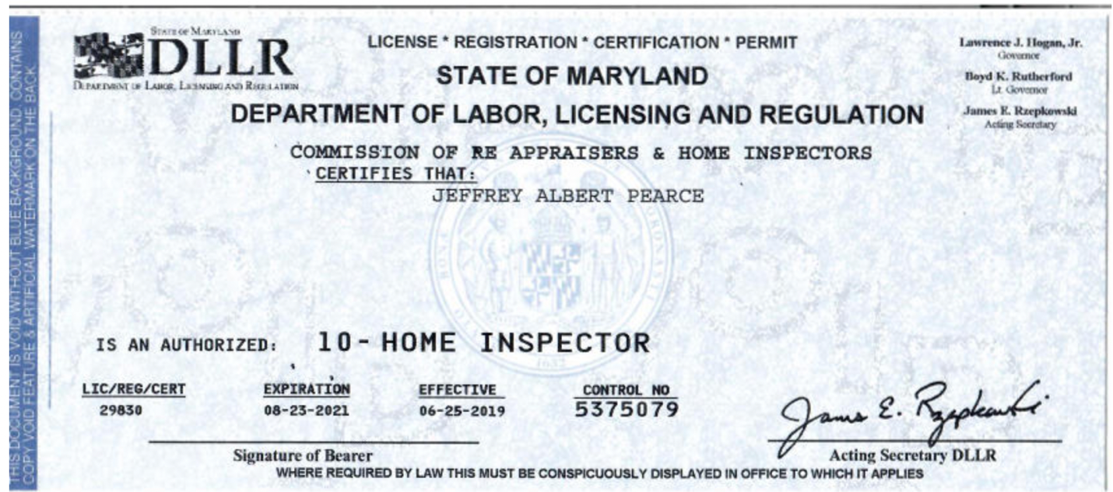

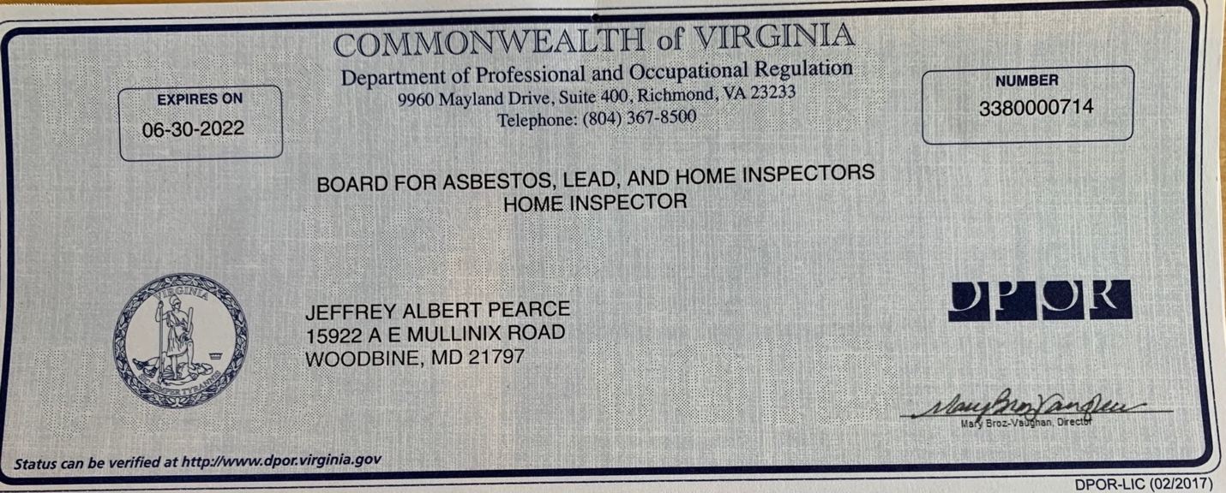



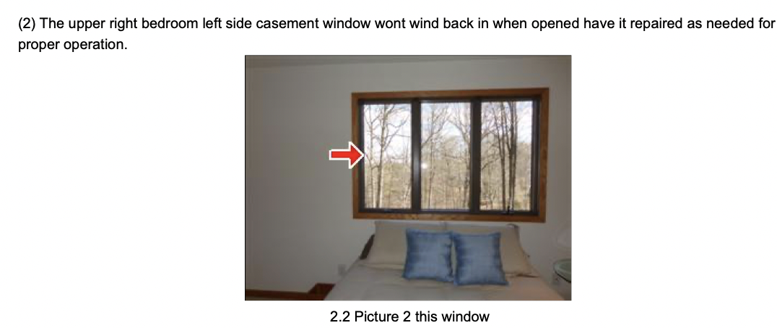

**1. Introduction**

1.1 Project Overview

*Executive Summary:*

The purpose of this project is to enhance the existing Pearce Group website, in order to add additional functionality and style to reach the ultimate goal of helping company operations run smoother. New home buyers, or customers, will now be able to book appointments online and cancel appointments online. Buyers and agents will be able to use the messaging forum to communicate with the company and receive a response about their inquiry. The owner will be able to in return communicate back with these buyers and agents via the contact information provided, to get all their questions answered. The website will also provide all necessary company information to supply all clients with the appropriate information they will need in a visually appealing way.

1.2 Project Deliverables

Design Review Meeting 03-31-21 12-12:30 online

Tool Selection Meeting 03-31-21 12-12:30 online

Project Presentation 05-03-21 7:00 online

1.3 Evolution of the SPMP

*Plans for change:*

When change occurs, whether anticipated or unanticipated, the plan is to schedule a meeting with Professor Broadwater ASAP to come up with a solution to the change’s effect on the project. Hopefully, negative change can be avoided by starting all project requirements early to account for mishaps along the way.

1.4 Reference Materials

- Class PPTs

- Existing Pearce Group website (tpginspect.com)

1.5 Definitions and Acronyms

TPG – The Pearce Group

SPMP – Software Project Management Plan

**2. Project Organization**

2.1 Process Model

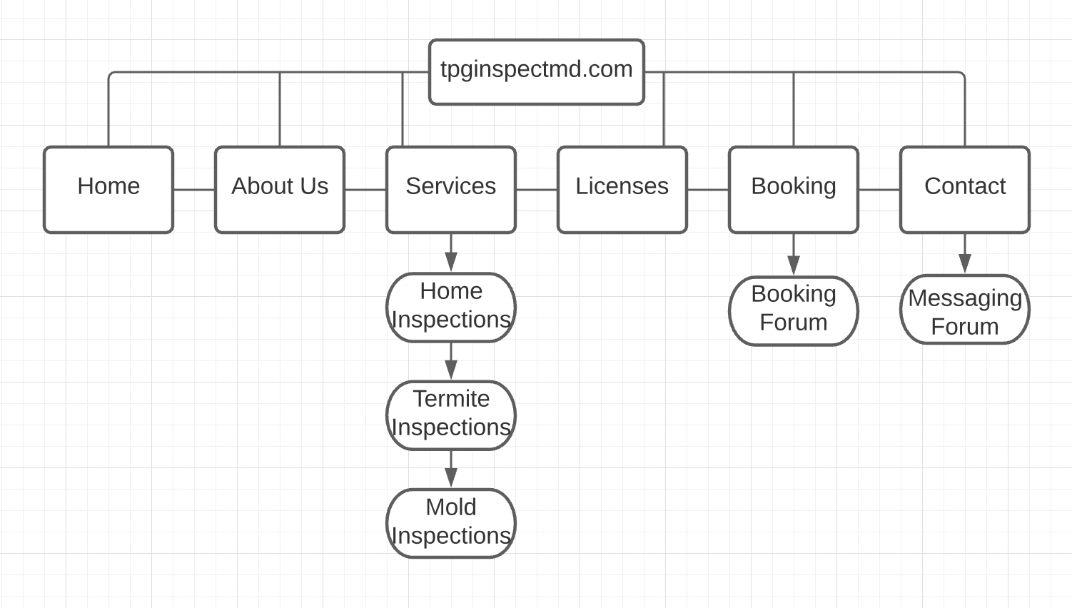

2.2 Organizational Structure

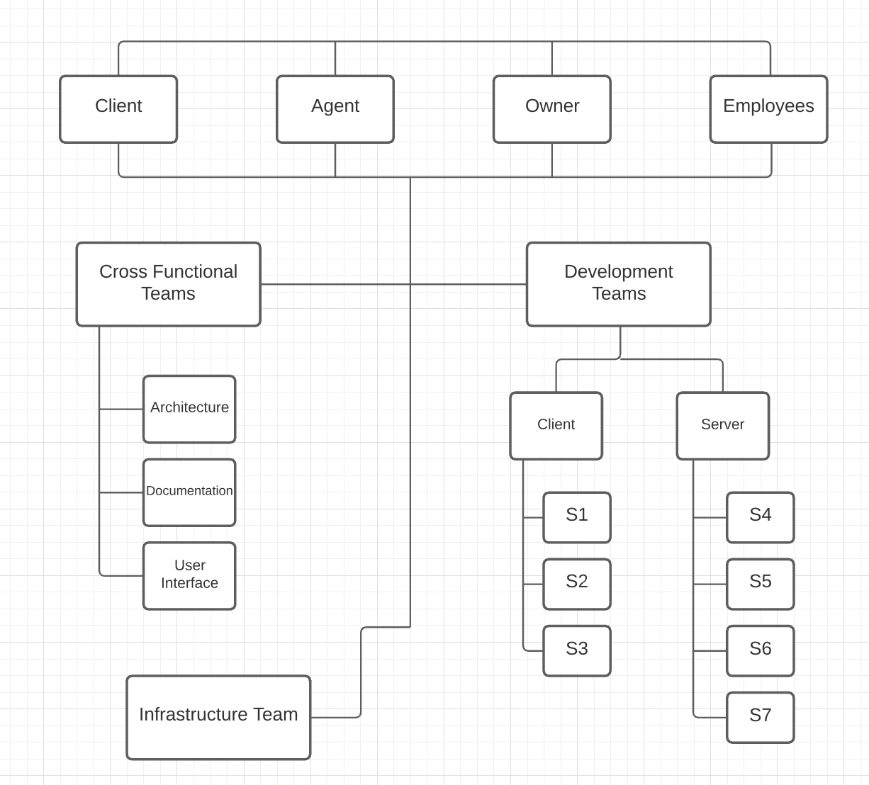

2.3 Organizational Interfaces

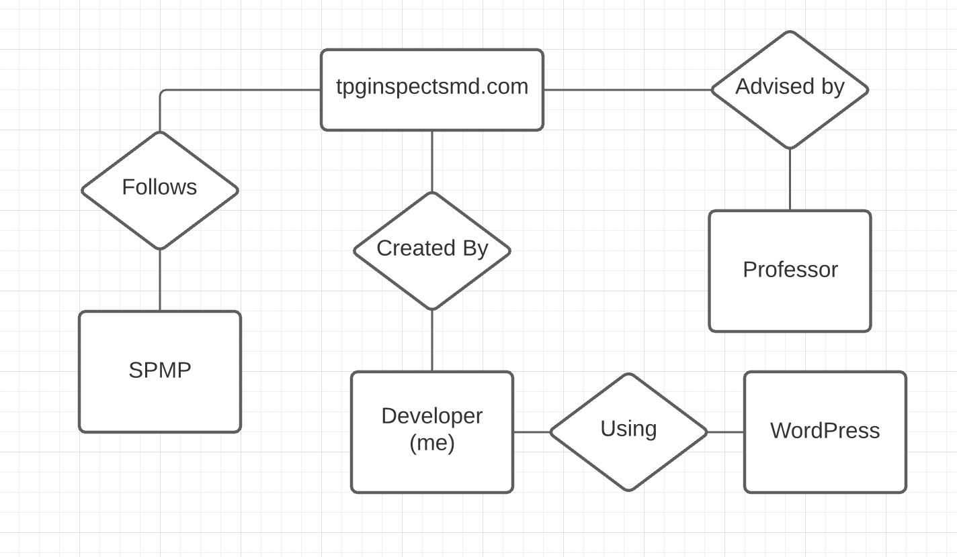

2.4 Project Responsibilities

*Major functions and responsibilities:*

* Book and cancel appointments via Booking tab
* Message the company via Contact tab
* Provide an overview of company services/pricing/employees/qualifications

**Sydney is in charge of all functions**

**3. Managerial Process**

3.1 Management Objectives and Priorities

*Management Philosophy:*

The management philosophy is to approach all tasks early and with full effort. Ultimately, the goal is to design the best visually appealing website with all around functionality to help the company run as efficiently as possible.

*Priorities Among Requirements:*

1. Full functionality of booking system for clients
2. Full functionality of messaging forum for clients/agents

*Gannt Chart (Schedule):* 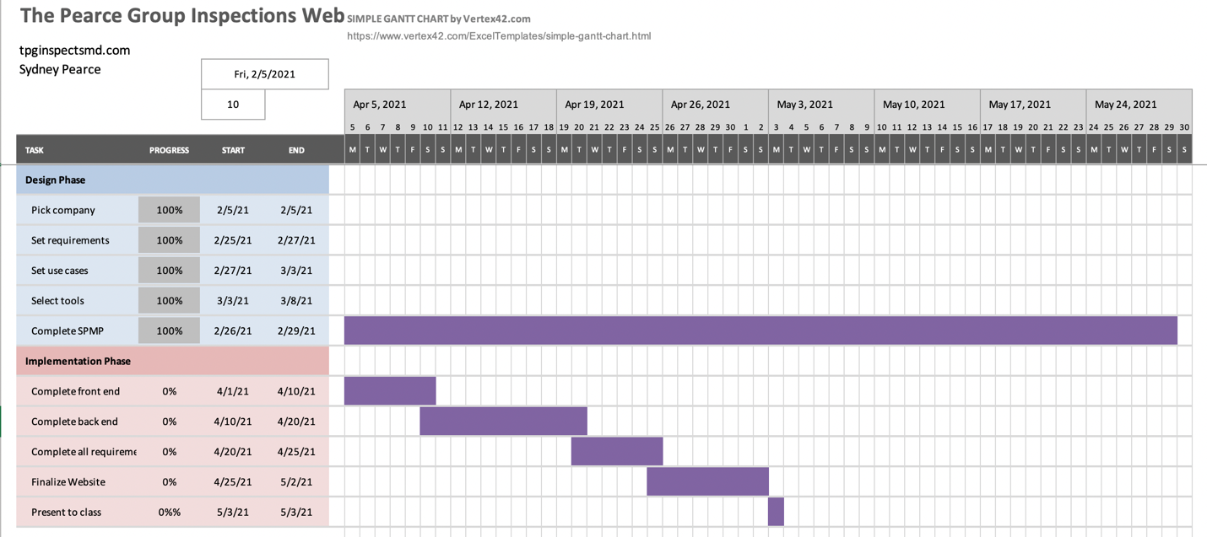

Budget($50) – For domain name and WordPress

3.2 Assumptions, Dependencies, and Constraints

This project depends on myself, as the developer, learning to use all appropriate tools to construct the website. The constraints that exist are having enough time to dedicate to the project, since there is also a group project to complete, as well as other demanding classes.

3.3 Risk Management

*Contractual Risks*

If the client becomes bankrupt, the project budget will be adjusted to fit the situation and the website will be created accordingly.

*Size of The Project*

If the project is too large, the requirements will be scaled back in order of least necessary. This will hopefully be avoided through careful planning and scheduling.

*Complexity of The Project*

If the requirements begin to multiply during analysis, as the developer I will take a step back to analyze what I will be able to get done before the due date. Some requirements will be cut out accordingly.

*Client Acceptance*

If the client does not like the developed prototype, dislikes will be documented and changed accordingly. Another review will then take place until the client is happy.

3.4 Monitoring and Controlling Mechanisms

Reporting should take place after each task is completed according to the Gannt Chart. If there are any issues along the way, meetings will be scheduled with Professor Broadwater to address them.

**4. Technical Process**

4.1 Methods, Tools, and Techniques

For the implementation of the project, WordPress will be used to declare the domain name and add the necessary design and functionality. WordPress was chosen due to multiple recommendations, and its easy to learn structure. JavaScript and CSS may be used in the process of adding functionality and style, respectively.

4.2 Software Documentation

I will use a spreadsheet to document all software processes. The requirements will be documented when completed, and any errors/bug fixes needed will be noted for future attention.

4.3 Project Support Functions

*Plan to ensure quality assurance:*

The finished project must meet the following criteria:

* Display all appropriate company information, organized into multiple tabs, in a visually exciting way for clients.
* Clients should be able to successfully book and cancel appointments, while receiving either a success message or error message.
* Clients and agents should be able to successfully message the owner via the website messaging platform, and the owner in return should be able to view this message to get in contact.
* Have a working database to store client bookings.
* Verify the client is a human and not robot upon booking appointment.

*Configuration management plan:*

In order to provide configuration audits, Sydney will provide weekly reports to establish what has been completed, and what still needs to be completed. The status of the project will be reviewed bi-weekly to ensure the website is on track to be finished by its deadline. In the appearance of change, the developer will follow plans for change outlined in section 1.3 of the SPMP.

*Verification and validation plan:*

*Verification*: In order to establish compliance with all requirements, the quality assurance checklist will be followed daily to ensure all tasks are met before the presentation. This means the booking and messaging platforms must be up and running to full capability before the website is to be presented.

*Validation*: In order to establish that the website meets The Pearce Group’s expectations, weekly check-ins will be deployed to ensure all requirements are met, and that the style of the website is liked by the client.

**5. Description of Work Packages**

5.1 Work Breakdown Structure (WBS)

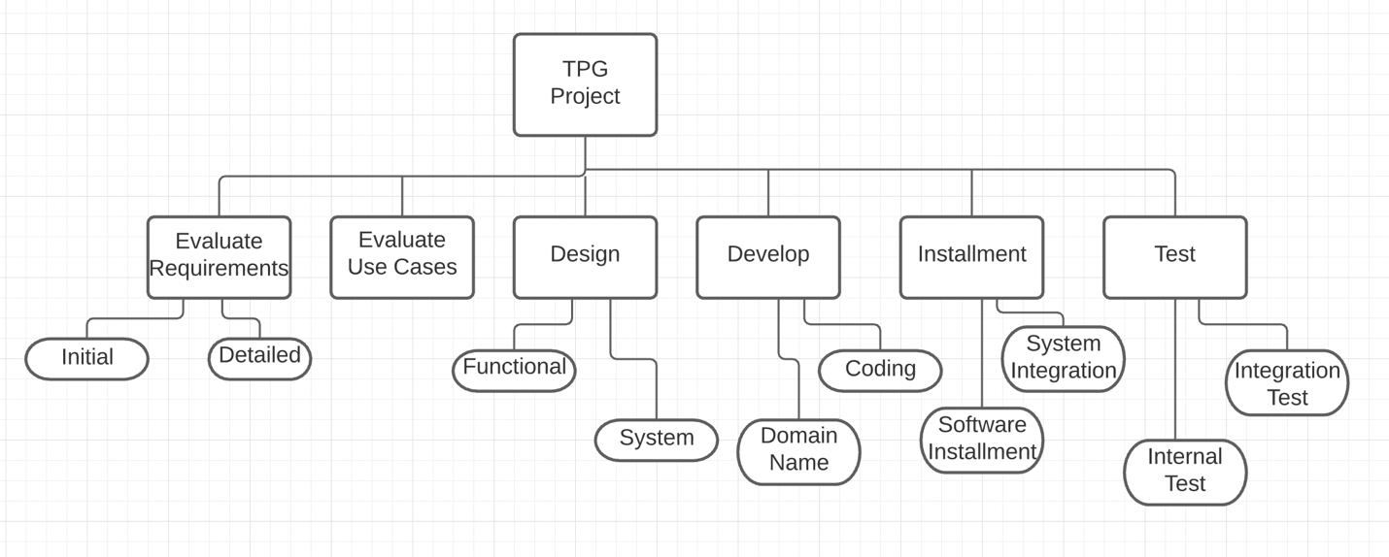

5.2 Dependencies Between Tasks

The design of the website depends on the detailed requirements planned out, as well as the use cases outlined in the planning process. In order to develop the features in the back end, the design/front end must first be developed. The integration of the front and back-end components depends on both being successfully developed in a timely manner. In order to test and present the website, all requirements and functions must be successfully developed.